

2019/2020

Lab 6: Generic Class & Tree

FAKULTI TEKNOLOGI KEJURUTERAAN KELAUTAN DAN INFORMATIK

**DATA STRUCTURE & ALGORITHM**



**VERSION 1**

STUDENT INFORMATION

**Please fill in your details:**

**Name: arun mugilan**

**MATRIC NUMBER:s63746**

**GROUP:k2**

**LAB:MP3**

**DATE:13/12/2022**

Table of Contents

INSTRUCTIONS 1

TASK 1: Understanding The Concept Of Generic Class 2

TASK 2: Implementing A General Tree 7

TASK 3: Develop A Tree With Double Data Type 13

# INSTRUCTIONS

Manual makmal ini adalah untuk kegunaan pelajar-pelajar Fakulti Teknologi Kejuruteraan Kelautan dan Informatik, Universiti Malaysia Terengganu (UMT) sahaja. Tidak dibenarkan mencetak dan mengedar manual ini tanpa kebenaran rasmi daripada penulis.

Sila ikuti langkah demi langkah sebagaimana yang dinyatakan di dalam manual.

*This laboratory manual is for use by the students of the Faculty of Ocean Engineering Technology and Informatics, Universiti Malaysia Terengganu (UMT) only. It is not permissible to print and distribute this manual without the official authorisation of the author.*

*Please follow step by step, as described in the manual.*

# TASK 1: Understanding the concept of generic class

## Objective

In this task, students must be able to:

* Understand the concept of generic classes.
* Implement generic classes using Java.

## Estimated Time

[60 Minutes]

### definition of generic classes

Generics in Java is similar to templates in C++. The idea is to allow type (Integer, String, .etc and user-defined types) to be a parameter to methods, classes and interfaces. For example, classes like HashSet, ArrayList, HashMap, etc use generics very well. We can use them for any type.

Like C++, we use <> to specify parameter types in generic class creation. To create objects of generic class, we use following syntax.

// To create an instance of generic class

BaseType <Type> obj = new BaseType <Type>()

**Note:** In Parameter type we can not use primitives like 'int','char' or 'double'.

A generic class declaration looks like a non-generic class declaration, except that the class name is followed by a type parameter section.

As with generic methods, the type parameter section of a generic class can have one or more type parameters separated by commas. These classes are known as parameterised classes or parameterised types because they accept one or more parameters.

### Naming conventions for type parameters

By convention, type parameter names are single, uppercase letters. This stands in sharp contrast to the variable naming conventions that you already know about, and with good reason: Without this convention, it would be difficult to tell the difference between a type variable and an ordinary class or interface name.

The most commonly used type parameter names are:

* E - Element (used extensively by the Java Collections Framework)
* K - Key
* N - Number
* T - Type
* V - Value
* S,U,V etc. – 2nd , 3rd , 4th types

**Important Notes:**

Type Parameter and Type Argument Terminology: Many developers use the terms "type parameter" and "type argument" interchangeably, but these terms are not the same. When coding, one provides “type arguments” in order to create a “parameterized type”. Therefore, the T in Foo<T> is a type parameter, and the String in Foo<String> f is a type argument. This lesson observes this definition when using these terms.

### steps:

1. Open NetBeans and create a new java application project.
2. Name your project as GenericsExperiment and click finish.
3. Change author profiles to :
   1. Name :
   2. Program: <put your program. E.g., SMSK(SE) or SMSK with IM
   3. Course : CSF3104
   4. Lab : <enter lab number>
   5. Date : <enter lab date>
4. In the same GenericsExperiment project’s package, create a new file named NonGenericClass.java.
5. Add the following codes to the file:

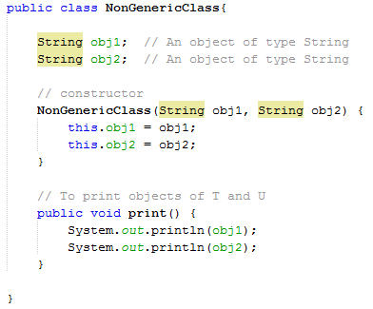

1. Now, create a test class to test the above class. Name your test class as GenericClassDemo.java. Your output should look like below:



1. Next, we are going to modify the above class to become a generic class.
2. Create a new file and name it as MyGenericClass.java.
3. Add <T, U> after the name of the class (see below). For this example, we put T and U in the parameter section to represent the generic type.



1. Copy the codes from NonGenericClass.java and paste it to the body of MyGenericClass class. Modify it to make it looks like follows:

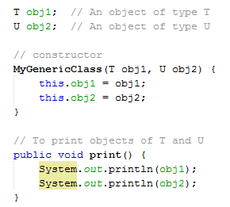

1. It’s time to test your class. Use the previous test class to test MyGenericClass. Unlike previous steps, where we have supplied the class with String parameters, this time we are going to supply a String and an Integer as parameters to the class. So, part of the codes in the main method should look like below:

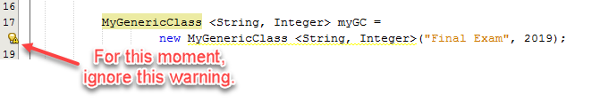

1. Save and compile your codes, and your output should look like below:

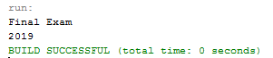

1. Let’s go back to discuss the warning appear in Netbeans:

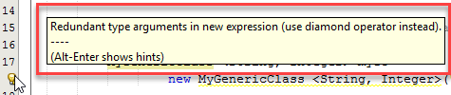

Starting from Java SE 7 and later, you can replace the type arguments required to invoke the constructor of a generic class with an empty set of type arguments (<>) as long as the compiler can determine, or infer, the type arguments from the context. This pair of angle brackets, <>, is informally called the **diamond**. For example, you can create an instance of MyGenericClass <String, Integer> with the following statement:

MyGenericClass <String, Integer> myGC =

new MyGenericClass **<>**("Final Exam", 2019);

1. Fix the codes by following the above example and observe the output. Do the warnings disappear?

**Answer:**

**Yes**

1. Copy and paste your Java codes into the text box below:

**Answer:**

public class NonGenericClass {

String obj1;

String obj2;

NonGenericClass(String obj1, String obj2){

this.obj1=obj1;

this.obj2=obj2;

}

public void print(){

System.out.println(obj1);

System.out.println(obj2);

}

}

public class MyGenericClass<T, U> {

T obj1;

U obj2;

MyGenericClass(T obj1, U obj2){

this.obj1=obj1;

this.obj2=obj2;

}

public void print(){

System.out.println(obj1);

System.out.println(obj2);

}

}

public class GenericClassDemo {

public static void main(String[] args) {

NonGenericClass x=new NonGenericClass("Final", "Exam");

x.print();

MyGenericClass <String, Integer> mygc=new MyGenericClass <>("Final",2022);

mygc.print();

}

}

### questions

1. Discuss the differences between Non-generic and generic classes.

**Answer:**

Click or tap here to enter text.

1. Beside Class, where else you can apply Generics?

**Answer:**

Click or tap here to enter text.

1. List the advantages of using Generics in Java.

**Answer:**

Click or tap here to enter text.

# TASK 2: implementing A general tree

## objective

In this task, students must be able to:

* Understand the concept of Tree data structure.
* Implement generic classes for Tree.

## estimated time

[45 Minutes]

### iNTRODUCTION TO TREE

There are many basic data structures that can be used to solve application problems. Array is a good static data structure that can be accessed randomly and is fairly easy to implement. Linked Lists on the other hand is dynamic and is ideal for application that requires frequent operations such as add, delete, and update. One drawback of linked list is that data access is sequential. Then there are other specialized data structures like, stacks and queues that allows us to solve complicated problems (e.g.: Maze traversal) using these restricted data structures. One other data structure is the hash table that allows users to program applications that require frequent search and updates. They can be done in O(1) in a hash table.

One of the disadvantages of using an array or linked list to store data is the time necessary to search for an item. Since both the arrays and Linked Lists are **linear structures**the time required to search a “linear” list is proportional to the size of the data set. For example, if the size of the data set is n, then the number of comparisons needed to find (or not find) an item may be as bad as some multiple of n. So, imagine doing the search on a linked list (or array) with n = 106 nodes. Even on a machine that can do million comparisons per second, searching for m items will take roughly m seconds. This not acceptable in today’s world where speed at which we complete operations is extremely important. Time is money. Therefore it seems that better (more efficient) data structures are needed to store and search data.

In this chapter, we can extend the concept of linked data structure (linked list, stack, queue) to a structure that may have multiple relations among its nodes. Such a structure is called a **tree**. A tree is a collection of nodes connected by directed (or undirected) edges. A tree is a *nonlinear* data structure, compared to arrays, linked lists, stacks and queues which are linear data structures. A tree can be empty with no nodes or a tree is a structure consisting of one node called the **root** and zero or one or more subtrees. A tree has following general properties:

* One node is distinguished as a **root**;
* Every node (exclude a root) is connected by a directed edge *from* exactly one other node; A direction is: *parent -> children*

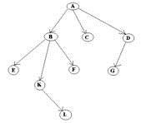

* A is a parent of B, C, D,  
  B is called a child of A.  
  on the other hand, B is a parent of E, F, K

In the above picture, the root has 3 subtrees.

Each node can have *arbitrary* number of children. Nodes with no children are called **leaves**, or **external** nodes. In the above picture, C, E, F, L, G are leaves. Nodes, which are not leaves, are called **internal** nodes. Internal nodes have at least one child.

Nodes with the same parent are called **siblings**. In the picture, B, C, D are called siblings.  The **depth of a node** is the number of edges from the root to the node. The depth of K is 2.  The **height of a node** is the number of edges from the node to the deepest leaf. The height of B is 2. The **height of a tree** is a height of a root.

### steps:

1. Given below is the example of a general Tree structure. In this task, we will do the implementation of a tree data structure using generic class.

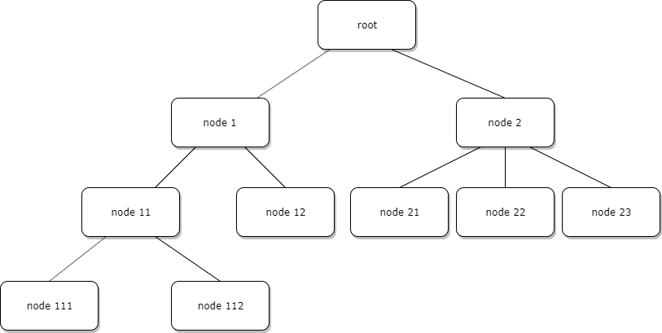

1. First, open NetBeans and create new java application project.
2. Name your project as TreeExperiment and click finish.
3. Change author profiles to :
   1. Name :
   2. Program: <put your program. E.g., SMSK(SE) or SMSK with IM
   3. Course : CSF3104
   4. Lab : <enter lab number>
   5. Date : <enter lab date>
4. In the same TreeExperiment project’s package, create a new file named Node.java and insert the following codes:

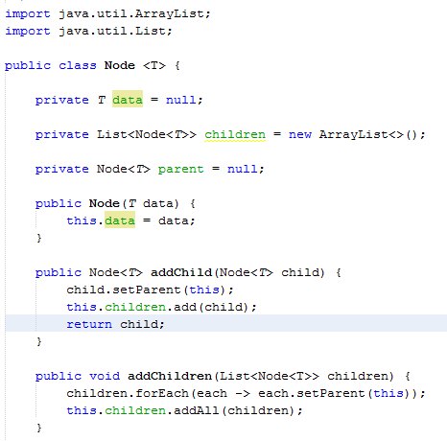

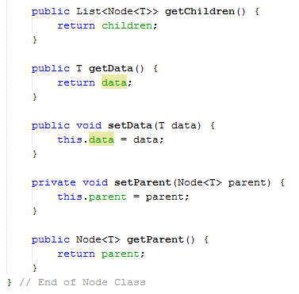

1. Next, create a test class for Node.java. This test class will create a tree as described in Step 1.

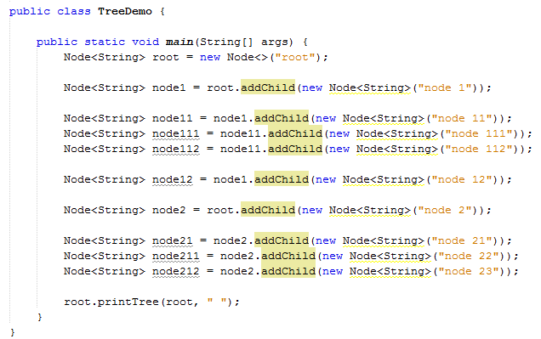

1. Save, compile and run your source code. Observe the output. A correct output should look like below:

root

node 1

node 11

node 111

node 112

node 12

node 2

node 21

node 22

node 23

1. Print screen your output from NetBeans and upload it using the following control box:

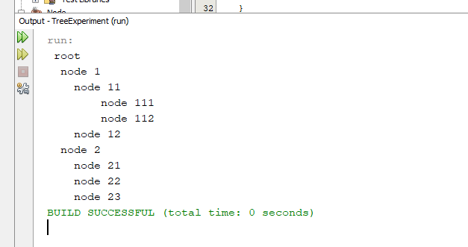

1. Copy and paste your Java codes from NetBeans into text box below:

import java.util.ArrayList;

import java.util.List;

public class Node<T> {

private T data=null;

private List<Node<T>> children = new ArrayList<>();

private Node<T> parent=null;

public Node(T data){

this.data=data;

}

public Node<T> addChild(Node<T> child){

child.setParent(this);

this.children.add(child);

return child;

}

public void addChildren(List<Node<T>> children){

children.forEach(each-> each.setParent(this));

this.children.addAll(children);

}

public List<Node<T>> getChildren(){

return children;

}

public T getData(){

return data;

}

public void setData(T data){

this.data=data;

}

private void setParent(Node<T> parent){

this.parent=parent;

}

public Node<T> getParent(){

return parent;

}

public static<T> void printTree(Node<T> node, String appender) {

System.out.println(appender + node.getData());

node.getChildren().forEach(each-> printTree(each, appender+appender));

}

}

public class TreeDemo {

public static void main(String[] args) {

Node<String> root = new Node<>("root");

Node<String> node1 = root.addChild(new Node<String>("node 1"));

Node<String> node11 = node1.addChild(new Node<String>("node 11"));

Node<String> node111 = node11.addChild(new Node<String>("node 111"));

Node<String> node112 = node11.addChild(new Node<String>("node 112"));

Node<String> node12 = node1.addChild(new Node<String>("node 12"));

Node<String> node2 = root.addChild(new Node<String>("node 2"));

Node<String> node21 = node2.addChild(new Node<String>("node 21"));

Node<String> node211 = node2.addChild(new Node<String>("node 22"));

Node<String> node212 = node2.addChild(new Node<String>("node 23"));

root.printTree(root, " ");

}

}

### questions

1. List the basic operations in tree data structure.

**Answer:**

Click or tap here to enter text.

1. Where can we apply tree data structure in a software development?

**Answer:**

Click or tap here to enter text.

1. Write algorithm for finding the root of tree from any node.

**Answer:**

Click or tap here to enter text.

# TASK 3: develop a tree with double data type

## objective

During this activity, students will apply a general tree concept in a simple programming task. A student should understand how tree works.

## estimated time

[30 Minutes]

## Introduction

For this task, every node in a tree holds data with a double data type.

### steps:

1. Open previously created Netbeans project.
2. Create a new class named DoubleTypeTreeDemo.
3. In DoubleTypeTreeDemo.java, create a test class for the following tree structure:

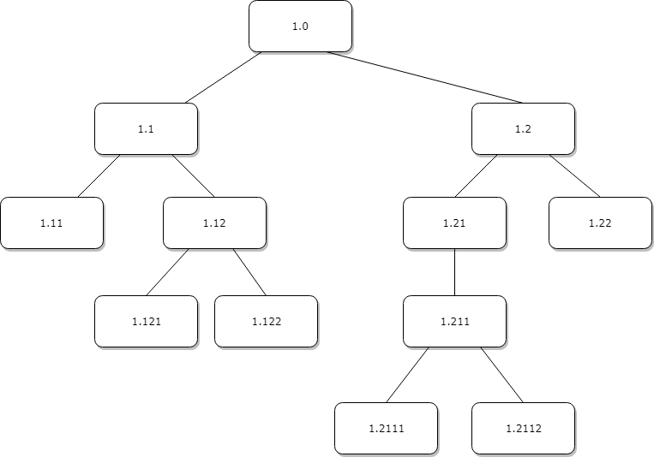

1. Save, compile and execute your codes.
2. Upload your output using the control box below:

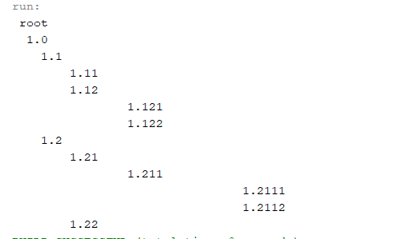

1. Copy and paste your Java codes from NetBeans into text box below:

public class DoubleTypeTreeDemo {

public static void main(String[] args) {

Node<String> root = new Node<>("root");

Node<String> node1 = root.addChild(new Node<String>("1.0"));

Node<String> node11 = node1.addChild(new Node<String>("1.1"));

Node<String> node111 = node11.addChild(new Node<String>("1.11"));

Node<String> node112 = node11.addChild(new Node<String>("1.12"));

Node<String> node1121 = node112.addChild(new Node<String>("1.121"));

Node<String> node1122 = node112.addChild(new Node<String>("1.122"));

Node<String> node12 = node1.addChild(new Node<String>("1.2"));

Node<String> node121 = node12.addChild(new Node<String>("1.21"));

Node<String> node122 = node12.addChild(new Node<String>("1.22"));

Node<String> node1211 = node121.addChild(new Node<String>("1.211"));

Node<String> node12111 = node1211.addChild(new Node<String>("1.2111"));

Node<String> node12112 = node1211.addChild(new Node<String>("1.2112"));

root.printTree(root, " ");

}

}

### questions

1. Explain about 3 types tree traversals.

**Answer:**

Click or tap here to enter text.

1. What is a binary tree?

**Answer:**

Click or tap here to enter text.

1. How binary differs from a general tree?

**Answer:**

Click or tap here to enter text.

Finally, read the instruction regarding submission carefully. Submit your answer using the link provided in Oceania UMT. Please ensure your codes are submitted to the correct group.